**Can *soybean vein necrosis virus* be managed through host plant resistance?**

**Asifa Hameed, graduate student in Entomology**

**And**

**Ed Rajotte, Professor of Entomology**

**Penn State University**

**Pennsylvania Soybean Association Project 199751**

**Final Report**

**Introduction:**

Soybean (*Glycine max*) is an important food, forage, livestock feed and potential biodiesel crop (Konovsky et al. 1994, Sarkar et al. 1997, Singh et al. 2007). In the US in 2018 soybeans were planted on 88 million hectares, with production of 4.428 billion bushels. This soybean seed is valuable source of livestock feed and domestic oil not only for United States but most of the countries in the world rely on import of these valuable products to meet feed and domestic oil requirement of their population. *Soybean vein necrosis virus* is a seed and vector (thrips) borne plant epidemic disease. In 2008 the disease was first identified in Tennessee (Zhou et al. 2011, Zhou and Tzanetakis 2013, Keough et al. 2016). After that in 2012 the disease was found in all soybean growing states in USA, and in 2013 the survey showed 22 US states were infected with *Soybean vein necrosis virus*. In 2012 the disease was also found in Canada. In 2017 the disease was first time reported in Egypt. It is meant that the disease is spreading rapidly in different geographic zones including the middle East. We in 2018 requested a grant funding from PSA to evaluate if **soybean vein necrosis virus be managed through the host plant resistance**.

The project had following objectives

1. Do soybean cultivars vary in their susceptibility to the soybean vein necrosis virus and vector population presence.?
2. Is the trichome density different in the soybean cultivars which possess a high level of resistance?
3. Does soybean vein necrosis virus affect the plant physiological system including photosynthesis rate and chlorophyll content. ?

For this purpose, we performed both the field experiments as well as the lab experiments. The detailed methodology is provided here.

**Field Experiment:**

* Ten cultivars of soybeans were planted in 2017 field year to determine the population fluctuation of thrips fauna.
* Ten soybean varieties viz., Sway SG3322, GrowMark FS(Hisoy HS39T60), Grow Mark FSHisoy HS30A-42, Mycogen 5N343R2, H3h-12R2, Hubner3917R2x, Syngenta S27-J7, SeedwaySG3555, Mycogen5N312R2, Syngenta NKS36Y6 were planted in Rockspring. No irrigation, fertilizer, herbicide or insecticide was applied during the whole growing season.
* Population dynamics of thrips on the soybean plants was observed through counting thrips with the use of hand lens on the plant leaves (upper, middle and lower trifoliate leaves) per plant. Five (5) leaves per niche were randomly selected. Observations were taken at weekly intervals until crop maturity.

***Assessment of grain quality parameters:*** Grain quality parameters viz., Oil content, carbohydrate content, protein content, 100 seeds weight, grain moisture content was recorded. Plant yield characters viz., plant height, number of pods per plant, and number of grains per pod, was calculated.

***Statistical analysis:***

Data was analyzed through Minitab 8.0. ANOVA analysis was done and means were compared through Tukey Kramer test at probability value 5%. Graphs were prepared through excel software

|  |  |  |  |
| --- | --- | --- | --- |
| **Variety Coding** | **Variety name** | **Variety Coding** | **Variety name** |
| V1 | Seedway SG3322 | V6 | Channel3917R2x |
| V2 | Growmark FS Hisoy HS39T60 | V7 | Syngenta S27-J7 |
| V3 | Growmark FS Hisoy HS30A-42 | V8 | SeedwaySG3555 |
| V4 | Mycogen 5N343R2 | V9 | Mycogen5N312R2 |
| V5 | Hubner H34-12R2 | V10 | Syngenta NKS36Y6 |

Species of thrips identified feeding on soybeans including the predatory species

* + *Aeolothrips dasciatus* - a predator thrips
  + *Neohydatothrips variabilis* - pest thrips known
  + *Echinothrips subflavus*
  + *Frankliniella occidentalis*
  + *Frankliniella tritici*
  + *Frankliniella scheltezii*
  + *Frankliniella fusca*

***Neohydatothrips variabilis* population on different cultivars**

Information Using Tukey Pairwise Comparisons: Variety

Grouping the Tukey Method and 95% Confidence

Variety N Mean Grouping

V6 12 0.808854 A

V5 12 0.719792 A B

V2 12 0.683333 A B

V8 12 0.579479 A B

V4 12 0.520833 A B

V3 12 0.477083 A B

V10 12 0.457813 A B

V7 12 0.448958 A B

V9 12 0.433333 A B

V1 12 0.377083   B

Means that do not share a letter are significantly different.

Tukey Simultaneous 95% Cis

Graphic display along with confidence intervals



Trichome density in different cultivars



Protein content in seed samples in different cultivars



Oil content in different seed samples in different cultivars



Fiber content in different cultivars and seed samples



Carbohydrate content in different cultivars



Yield in different cultivars



Correlation different parameters and *N. variabilis*

|  |  |  |  |  |  |  |
| --- | --- | --- | --- | --- | --- | --- |
|  | Trichomes | Protein | Carbohydrate | Oil | Fiber | Yield |
| *N. variabilis* | 0.025 | 0.095 | -0.078 | 0.032 | -0.019 | -0.021 |
| P-value | 0.880 | 0.562 | 0.631 | 0.844 | 0.905 | 0.897 |

**Lab experiment results:** Plant physiological parameters and the virus role: For lab experiment, 5 plants of each cultivar viz., V1, V8 and V6 were grown in growth chamber conditions in cages. There were 15 plants per cage. There were total 5 cages, control, Inoculated, Mock and Infected thrips + Virus. We had one other cage of Healthy thrips without virus but that growth chamber could not function properly and thrips died. So we are presenting the results of 4 cages only. Infected Thrips were in separate growth chamber while other 3 cages control, mock and the inoculated plants were in one growth chamber. After 2 months of sowing, infection of virus on all plants in the virus plus thrips treatment was observed which meant that none of the variety was immune. In the field experiment, resistant cultivars might be resistant because they were defending themselves against thrips presence due to the plant defensive compound and also thrips had choice but when we put all of the plant cultivar in one cage and released 10 thrips per each plant with virus to eat on them the all got virus so I thought maybe there is no immunity the field experiment resistance results are due to avoiding thrips population build so the final analysis does not include the interaction of cultivars and the treatment response because we pooled all of them together. The plant physiological parameters were recorded after one-month interval and the maturity parameters viz., the number of seeds per plant and the number of seeds per pod at the maturity time. The experiment started on October 28 and completed on May 29th. The plants took somewhat longer to mature. One reason was the plants were grown in the growth chamber conditions which although I tried to be comparable to field conditions, but may not be.

I used R version 3.5.3 for statistical analysis. For the field experiment I used Minitab.

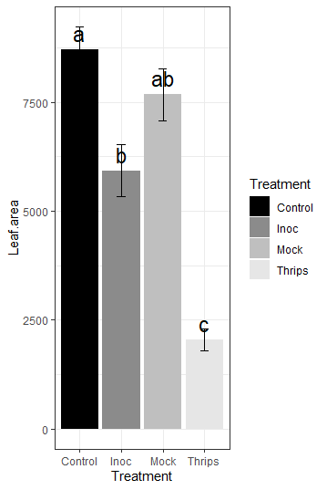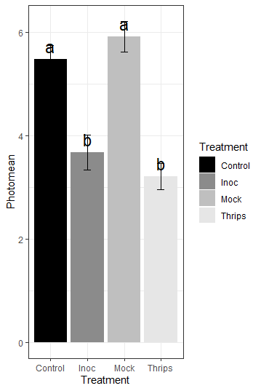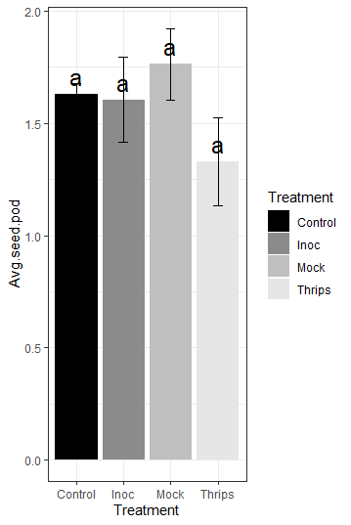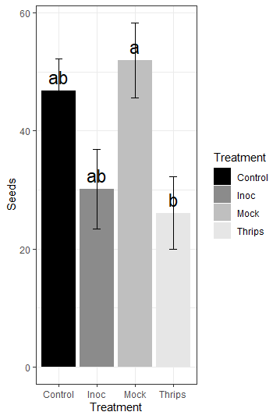

**Results and Discussion:**

1. In this experiment we found that soybean seeds vary in their susceptibility to the SVNV and the N. variabilis population fluctuation. The soybean cultivars.
2. The soybean cultivars which possessed high number of thrips had the higher SVNV incidence.
3. Overall, the cutivars which possessed higher trichomes density had lower number of thrips
4. Cultivars which possessed the higher number of thrips had high protein content but lower oil content
5. Yield was negatively correlated with thrips abundance
6. Leaf area had negative correlation with virus and thrips treatment
7. Plant photosynthesis was lowered in the thrips affected and virus affected plants
8. Average seed per pod was affected by thrips or virus
9. Number of seeds per plant were lower in the virus and thrips affected plants.

Acknowledgement:

I am highly thankful to you for providing me grant which helped me to complete my Ph.D experiments as well.

**References:**

**Keough, S., J. Han, T. Shuman, K. Wise, and P. Nachappa. 2016.** Effects of Soybean vein necrosis virus on life history and host preference of its vector, Neohydatothrips variabilis, and evaluation of vector status of Frankliniella tritici and Frankliniella fusca. Journal of economic entomology 109: 1979-1987.

**Konovsky, J., T. A. Lumpkin, and D. McClary. 1994.** Edamame: the vegetable soybean. Understanding the Japanese food and agrimarket: A multifaceted opportunity 1988: 173-181.

**Sarkar, P., L. Jones, G. Craven, S. Somerset, and C. Palmer. 1997.** Amino acid profiles of kinema, a soybean-fermented food. Food Chemistry 59: 69-75.

**Singh, R., G. Chung, and R. Nelson. 2007.** Landmark research in legumes. Genome 50: 525-537.

**Zhou, J., and I. E. Tzanetakis. 2013.** Epidemiology of Soybean vein necrosis-associated virus. Phytopathology 103: 966-971.

**Zhou, J., S. Kantartzi, R.-H. Wen, M. Newman, M. Hajimorad, J. Rupe, and I. Tzanetakis. 2011.** Molecular characterization of a new tospovirus infecting soybean. Virus genes 43: 289.